Commodore PET Joystick Adapter Rev. 0
Testing

Test Setup
- Commodore CBM3016 computer
- Three C64 Joysticks
- PET Joystick Adapter Rev. 0
- SD2PET future with software
- Cassette Port Dongle from the C64 diagnostic harness for supplying powering
- C64 Control Port Switch/Rapid Fire
- FNRSI
- PC speakers

Test Execution
The Joysticks were connected to all joystick/DSub connectors on the joystick adapter. The user port bits were displayed with the test software uptest.prg.
Coyote Electronics:
Port | Direction | User Port | Result
1 | Up | PA0 | ☑
1 | Down | PA1 | ☑
1 | Left | PA2 | ☑
1 | Right | PA3 | ☑
1 | Fire | PA0 & PA1 | ☑
2 | Up | PA4 | ☑
2 | Down | PA5 | ☑
2 | Left | PA6 | ☑
2 | Right | PA7 | ☑
2 | Fire | PA4 & PA5 | ☑

Space Invader +:
Direction | User Port | Result
Up | PA2 | ☑
Down | PA3 | ☑
Left | PA0 | ☑
Right | PA1 | ☑
Fire | PA4 & PA5 | ☑

The displayed user port bits were compared to the Coyote Electronics and the Space Invaders+ configuration. All bits were as expected.
The audio outputs were inspected with an oscilloscope. For this purpose, an oscilloscope was connected via an adapter cable and the following basic instruction were executed to generate a waveform on the user port CB2:
POKE59467,16
POKE59466,51
POKE59464,128
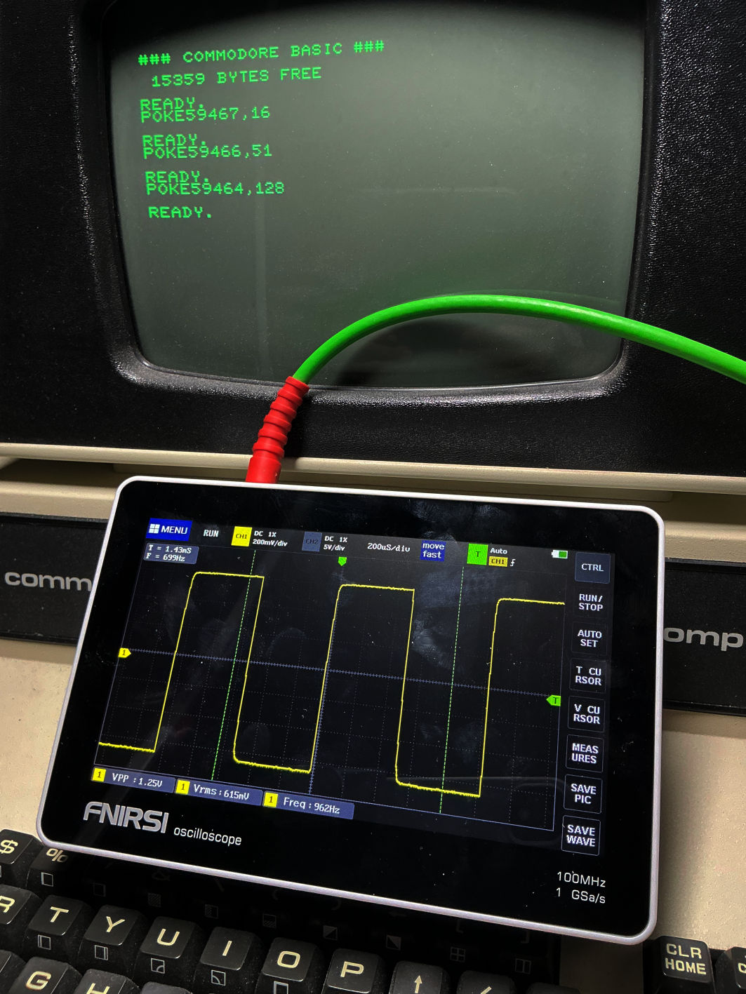Figure 1: CB2 audio wave form

The audio output is as desired. The amplitude was 1.25V_{PP} and 615mV_{RMS}, which is -4.2dBV (within the headroom of a -10dBV consumer audio line out). This level is no problem with standard audio equipment. In case this is too hot for your desire, you can replace the 27kΩ resistor in R4 with a 62kΩ resistor to get closer to the -10dBU.
The +5V supply was tested with an auto-fire circuit, which was connected to Port #1 and Port #2. A power supply was connected to the barrel connector and the auto-fire was powered properly. The same was tested while powering the device via the 6p pin header from the cassette port.
Finally, the games from zimmers.net were tested with the joystick adapter.

Game | Pin Configuration | Note
afo.prg | Coyote Electronics, port #1
arrow.prg | Coyote Electronics, port #1
bomber.prg | Coyote Electronics, port #1
break-out.prg | Coyote Electronics, port #1
breakout.prg | Coyote Electronics, port #1
brickwall.prg | Coyote Electronics, port #1
cosmiads uni.prg | Space Invaders+:LEFT=PA0, RIGHT=PA1, FIRE=PA5. | POKE 2571,79 before RUN for joystick on user port.
galaxy invdr joy.prg | Space Invaders+ (left/right/fire)
invaders.prg | Space Invaders+ LEFT=PA0, RIGHT=PA1, FIRE=PA5.
joystick_test.prg | Coyote Electronics, port #1&2
leap frog fix.prg | Space Invaders+ (4 dir)
pong joysticks.prg | port #1 & #2 (left/right: moves down/up)
print_racer.prg | Coyote Electronics, port #1
shark.prg | Coyote Electronics, port #1
space war.prg | ? | No joystick function found
star spores.prg | Space Invaders+
zap.prg | Coyote Electronics, port #1

Except space war.prg, all games were playable with one of either joystick pin configurations. It is not clear, if this program requires a poke to activate the joystick (like cosmiads uni) or is it does not even support joysticks. There was no reaction on any of the three ports, which actually should have been the case, since every user port bit can be manipulated this way.

Conclusion
The PET Joystick Adapter Rev. 0 is functional with the programs on zimmers.net, that support joystick and it seems, that the two pin configurations are the most popular ones.

